Name__________________
Grade__________________

LISTENING
Task 1. Listen to 10 dialogues and choose the right answer. In this task you will hear the dialogues twice.
- Who is Simon´s aunt?
- Where is Miguel from?
- Where does Will live?
- What is Sam’s last name?
- What nationality is Hans?
- What does Molly buy at the shops?

- What day is Ted’s birthday party?
- What is the time?
- Where is the cat?
- What shop is next to Billy’s house?

Task 2. Listen and write.
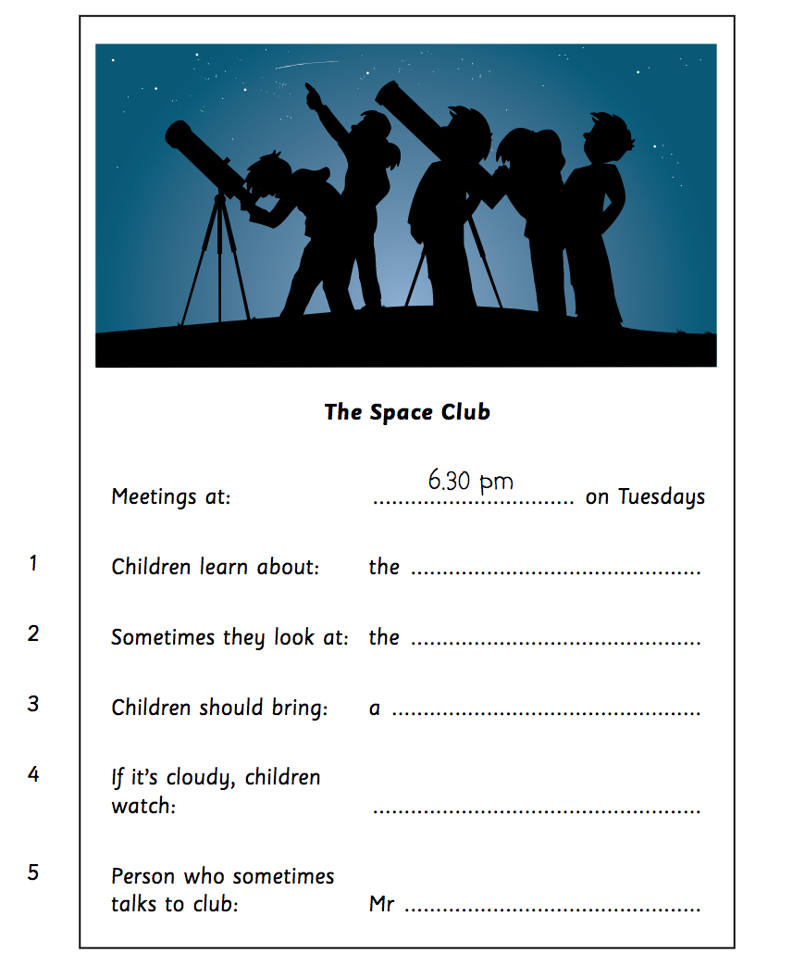

READING
Task 3. Read the extract from the book “The Wizard of Oz” by L. Frank Baum and choose TRUE, FALSE or NOT STATED.

The Witch and the monkeys

The next morning they left the Emerald City. The green man took away their glasses and told them the way to the
Witch’s house. “Everybody is afraid of the Witch of the West,” he said. “So be careful!”
The friends walked for a long time. The road was bad, and there were no houses, no fields, no trees.
Now the Witch of the West had a magic eye, and it could see everything. She saw the friends on the road, and
she was angry. She put on her tall black hat and shouted, “Magic Monkeys — come!”
In a second forty monkeys arrived at her tall house. “What do you want?” they asked.
“There are three people, a dog, and a lion on my road,” she said. “Kill the people and the dog. But bring the
lion here to my house. He can work for me.”
“At once!” said the Monkeys. And away they went. They broke the Tin Man’s arms and legs. They took all the
straw out of the Scarecrow and threw his clothes up into a tall tree. Then they took the Lion and carried him to a
dark cellar under the Witch’s house.
But they could not hurt Dorothy and Toto, because of the good Witch’s kiss. So the Monkeys picked them up
very carefully and carried them to the Witch’s house. The Witch saw the kiss on Dorothy’s face, and was afraid.
But she did not tell Dorothy that.
“You must work for me in my house now,” she said to the child. “All day, and every day. And remember — I
am watching you all the time.”
Now Dorothy did not know this, but the red shoes were magic. The Witch wanted those shoes very much, but
Dorothy never took them off. She took them off when she washed, of course, but the Witch never went near water.
She was very, very afraid of water.
Then, one morning, Dorothy’s left shoe fell off.
The Witch picked up the shoe at once. “This is my shoe now!” she shouted.
“No, it isn’t!” shouted Dorothy angrily. “Give it back to me at once!”
“No!” said the Witch. And then she tried to take Dorothy’s right shoe too.

Dorothy loved her red shoes, and she was very angry. There was a bucket of water near the door. Dorothy picked
up the bucket and threw the water at the Witch. The water hit her in the face, and she cried out, “Help! Help!
The water is killing me! The — water — is ...”
And then she disappeared! There was only her tall black hat and a long black dress.
Dorothy looked and looked, but the Witch was not there. Dorothy picked up her red shoe and put it on.
“Now, how can I help my friends?” she said. “Can I call the Magic Monkeys?” She picked up the Witch’s black
hat and looked at it. “Perhaps I must wear this magic hat when I speak.” So she put the hat on and called, “Magic
Monkeys — come!”
The Monkeys arrived in a second.
“Please can you help my friends?” asked Dorothy.
“Of course,” said the Monkeys. “We must always help the wearer of the magic black hat.”
They broke open the dark cellar, and the Cowardly Lion came out. “Free at last!” he said.
“Thank you!” and jumped. “Thank you!” he said. Then the Monkeys found the Scarecrow’s clothes and put
some new straw in them. The Scarecrow laughed.
1) All the citizens had a fear of the Witch.
A) True B) False C) Not stated

2) There were more than fourty monkeys.
A) True B) False C) Not stated

3) Some kind of magic helped Dorothy not to be hurt.
A) True B) False C) Not stated

4) Dorothy’s shoes were too big for her.
A) True B) False C) Not stated

5) The Monkeys helped Dorothy because they really wanted to do it.
A) True B) False C) Not stated

Task 4. Read the email and write the missing words. Write one word on each line.

Dear David
Tomorrow is my birthday. ………0 What ........... shall I do?
I’d like to go to a restaurant 1...................... you and my
other friends. We could have pizza and ice cream, but
Mum and Dad say it’s more fun to go to the park
and 2...................... football.
I think going to the restaurant is better 3............... going
to the park but I 4...................... everyone to enjoy
my birthday.
So I have decided to ask all my friends to choose.
Then I can tell Mum and Dad. What 5...................... you
like to do tomorrow?
Please email back quickly. Thanks!

